SCHOOL OF COMPUTER SCIENCE AND ARTIFICIAL INTELLIGENCE |  |  |  |  | DEPARTMENT OF COMPUTER SCIENCE ENGINEERING
ProgramName:B. Tech |  |  |  | Assignment Type: Lab |  |  | AcademicYear:2025-2026
CourseCoordinatorName |  |  |  | Venkataramana Veeramsetty
Instructor(s)Name
  Dr. V. Venkataramana (Co-ordinator)
  Dr. T. Sampath Kumar
  Dr. Pramoda Patro
  Dr. Brij Kishor Tiwari
  Dr.J.Ravichander
  Dr. Mohammand Ali Shaik
  Dr. Anirodh Kumar
  Mr. S.Naresh Kumar
  Dr. RAJESH VELPULA
  Mr. Kundhan Kumar
  Ms. Ch.Rajitha
  Mr. M Prakash
  Mr. B.Raju
  Intern 1 (Dharma teja)
  Intern 2 (Sai Prasad)
  Intern 3 (Sowmya)
  NS_2 ( Mounika)
CourseCode |  |  | 24CS002PC215 | CourseTitle |  | AI Assisted Coding
Year/Sem |  |  | II/I | Regulation |  | R24
Date and Day  of Assignment |  |  | Week3 - Wednesday | Time(s)
Duration |  |  | 2 Hours | Applicableto  Batches
AssignmentNumber:6.3(Present assignment number)/24(Total number of assignments)
 | Q.No. | Question |  |  |  |  |  | ExpectedTime  to complete
 | 1 | Lab 6: AI-Based Code Completion – Classes, Loops, and Conditionals  Lab Objectives:  - To explore AI-powered auto-completion features for core Python constructs.  - To analyze how AI suggests logic for class definitions, loops, and conditionals.  - To evaluate the completeness and correctness of code generated by AI assistants.  Lab Outcomes (LOs):  After completing this lab, students will be able to:  - Use AI tools to generate and complete class definitions and methods.  - Understand and assess AI-suggested loops for iterative tasks.  - Generate conditional statements through prompt-driven suggestions.  - Critically evaluate AI-assisted code for correctness and clarity.  Task Description#1 (Classes)  - Use AI to complete a Student class with attributes and a method.  - Check output  - Analyze the code generated by AI tool  Expected Output#1  - Class with constructor and display_details() method  Prompt: Generate a python function to complete a Student class with attributes and a method and allow user to give input to check the code.  Code:  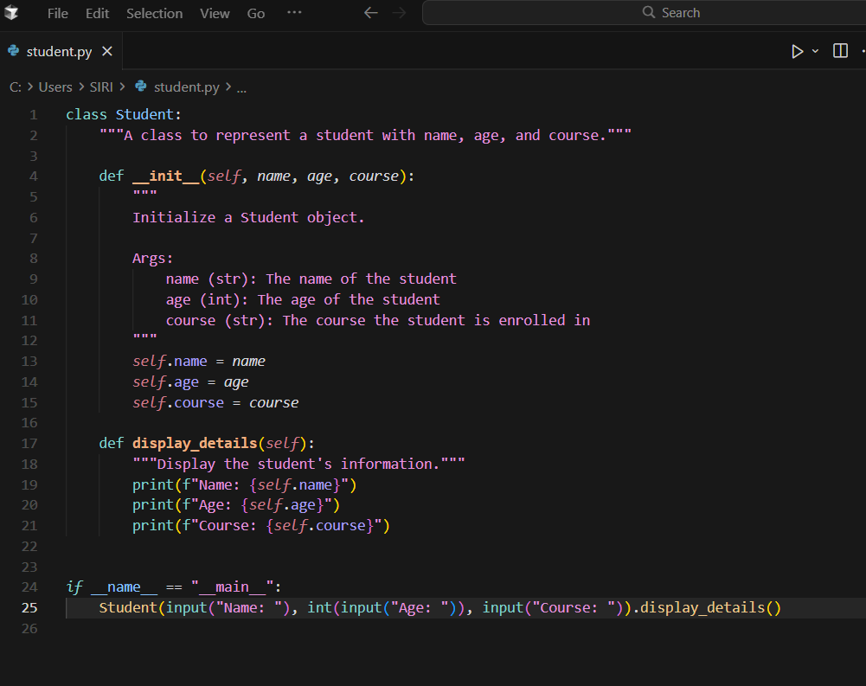  Code Explanation:  - Class definition: The Student class groups student data and behavior.  - Constructor (__init__): Creates a student with three attributes: name, age, course.  - Attributes: Each student stores name, age, and course as instance variables.  - Display method (display_details): Prints the student’s name, age, and course in a formatted way.  - User input: When run, prompts for name, age (converted to integer), and course, creates a Student, and displays the details.  Output: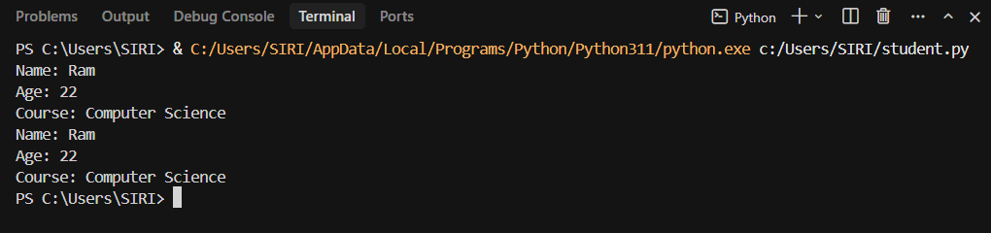  Task Description#2 (Loops)  - Prompt AI to complete a function that prints the first 10 multiples of a number using a loop.  - Analyze the generated code  - Ask AI to generate code using other controlled looping  Expected Output#2  - Correct loop-based implementation  Prompt-1: Generate a python function to complete a function that prints the first 10 multiples of a number using a loop.  Prompt-2: Allow user to give user input to check the code.  Code:  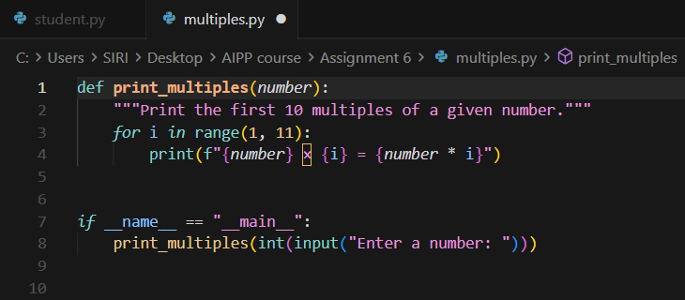  Code Explanation:  - Function definition: print_multiples(number) accepts a number and prints its first 10 multiples.  - Loop: for i in range(1, 11) runs from 1 to 10.  - Calculation and display: Inside the loop, it prints number × i = result (e.g., "5 × 3 = 15").  - User input: When the script runs, it prompts for a number, converts it to an integer, and passes it to the function.  - Execution flow: The function computes and prints each multiple from 1 to 10 in order.  Output:  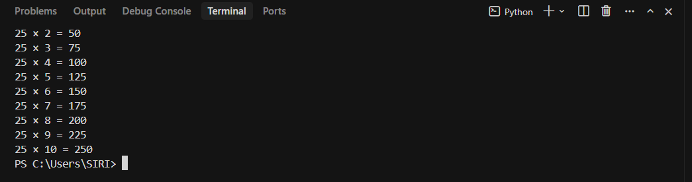  Task Description#3 (Conditional Statements)  - Ask AI to write nested if-elif-else conditionals to classify age groups.  - Analyze the generated code  - Ask AI to generate code using other conditional statements  Expected Output#3  - Age classification function with appropriate conditions and with explanation  Prompt-1: Generate a python function to use nested if-elif-else conditionals to classify age groups.  Prompt-2: Allow user to give input to test the code.  Code:  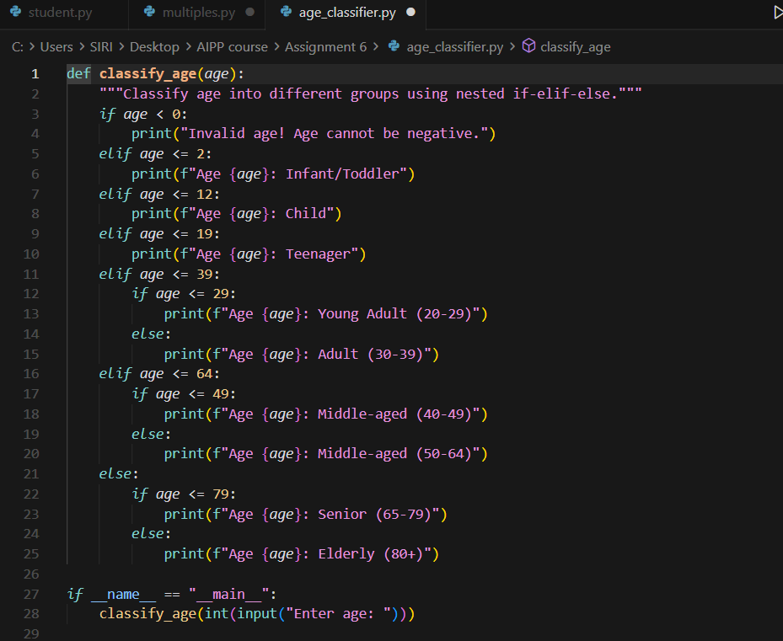  Code Explanation:  - Function definition: classify_age(age) takes an age and classifies it into groups using nested if-elif-else.  - Main conditional chain: The outer if-elif-else checks major ranges (negative, 0-2, 3-12, 13-19, 20-39, 40-64, 65+).  - Nested conditionals: Within some branches (e.g., 20-39, 40-64, 65+), inner if-else statements further refine the groups.  - Output: Prints the age group based on which condition matches.  - User input: When run, prompts for an age, converts it to an integer, calls the function, and prints the classification.  Output:  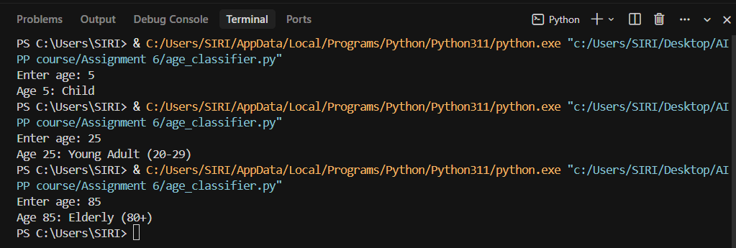  Task Description#4 (For and While loops)  - Generate a sum_to_n() function to calculate sum of first n numbers  - Analyze the generated code  - Get suggestions from AI with other controlled looping  Expected Output#4  - Python code with explanation  Prompt: Write a python function generate a sum_to_n() function to calculate sum of first n numbers and code should ask user for input.  Code (using for loop):  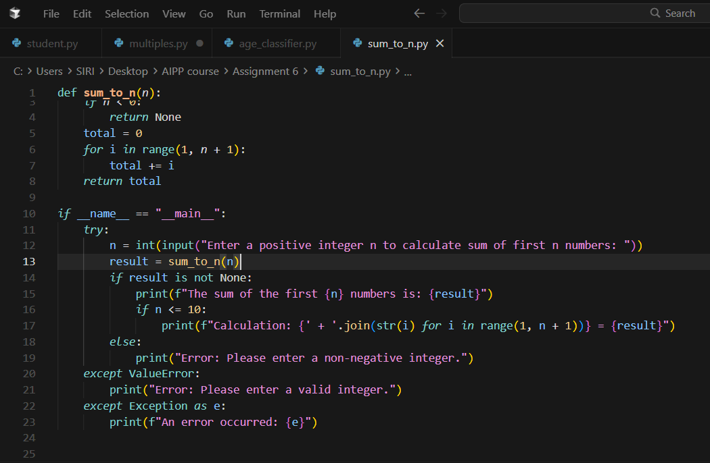  Code (using while loop):  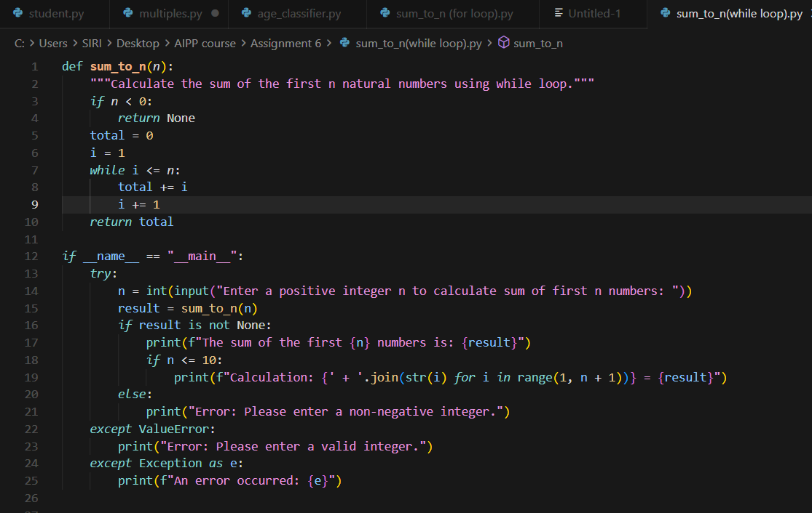  Code Explanation:  1. FUNCTION PURPOSE & INPUT VALIDATION:  - The sum_to_n(n) function calculates the sum of first n natural numbers (1 + 2 + 3 + ... + n).  - Input validation checks if n is negative and returns None for invalid input before any loop execution.  - Both for loop and while loop implementations produce the same result but differ in syntax and control.  2. FOR LOOP IMPLEMENTATION:  - Uses: for i in range(1, n + 1): total += i  - Counter variable i is automatically initialized and incremented by the range() function.  - The loop automatically stops after n iterations - no manual counter management needed.  - More concise and Pythonic for fixed iteration ranges.  3. WHILE LOOP IMPLEMENTATION:  - Uses: while i <= n: (with manual i = 1 initialization and i += 1 increment inside loop)  - Requires manual initialization (i = 1) before the loop and manual increment (i += 1) inside the loop.  - Loop continues as long as condition (i <= n) is true, giving more explicit control over iteration.  - More flexible for condition-based iteration where number of iterations is unknown.  4. KEY DIFFERENCES:  - INITIALIZATION: For loop handles it automatically via range(); While loop needs manual setup (i = 1).  - ITERATION CONTROL: For loop auto-increments via range(); While loop requires manual increment (i += 1).  - ERROR PRONENESS: For loop is safer (auto-managed); While loop can cause infinite loops if increment is forgotten.  - READABILITY: For loop is more concise for known iterations; While loop is more explicit about conditions.  - USE CASE: For loop is better for fixed ranges/sequences; While loop is better for condition-based iteration.  5. USER INPUT & RESULT DISPLAY:  - The main program uses try-except blocks to handle invalid input (non-integers) safely.  - Displays the calculated sum, and for small values (n ≤ 10), shows the calculation breakdown.  - Both implementations work identically with the same user input handling and error management.  Conclusion: Both loops achieve the same result, but for loop is simpler and more Pythonic for this fixed-range scenario, while while loop provides more manual control and is useful for understanding loop mechanics and condition-based iteration.  Output:  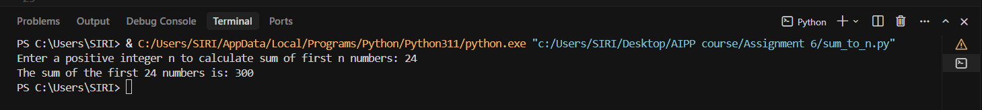  Task Description#5 (Class)  - Use AI to build a BankAccount class with deposit, withdraw, and balance methods.  - Analyze the generated code  - Add comments and explain code  Expected Output#5  - Python code with explanation  Prompt: Write a python function to to build a BankAccount class with deposit, withdraw, and balance methods and allow user to give user input to test the code.  Code:  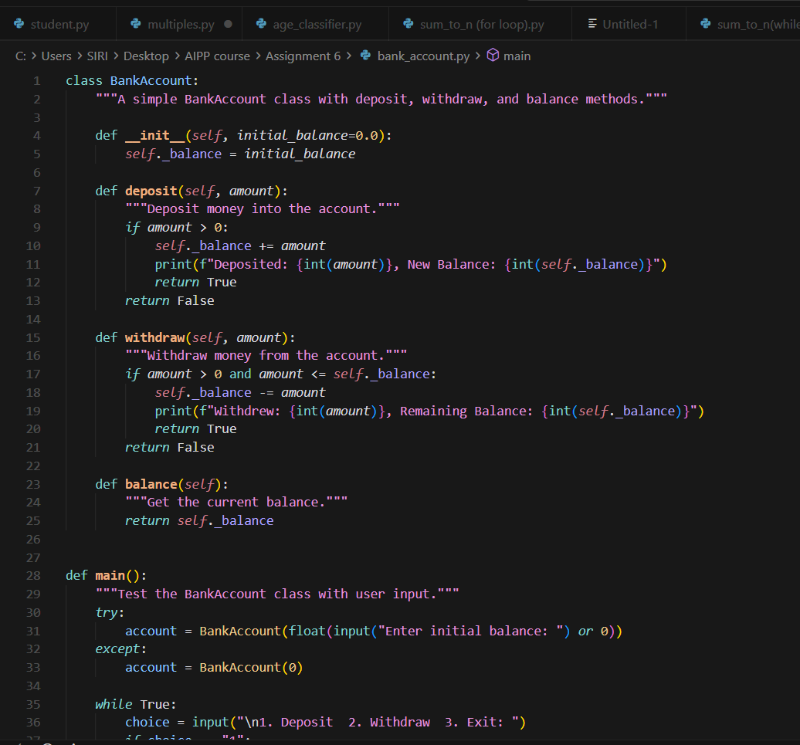  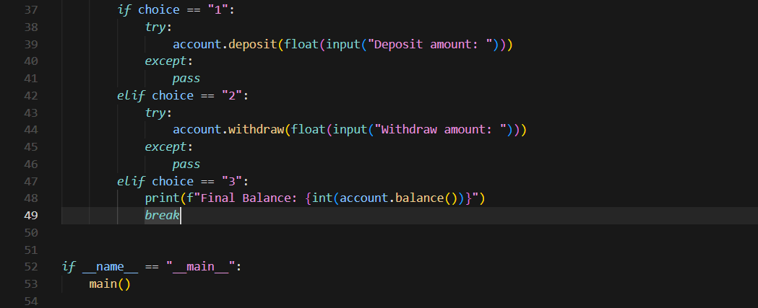  Code Explanation:  - Class Creation:  The program defines a BankAccount class that manages deposits, withdrawals, and balance tracking.  - Initialization:  The constructor __init__ sets an initial balance (default is 0.0) when a new account is created.  - Deposit & Withdraw Methods:  -> deposit(amount) adds money to the balance if the amount is positive.  -> withdraw(amount) subtracts money if the amount is valid and available in the account.  - Balance Check:  The balance() method simply returns the current account balance.  - Main Function (User Interaction):  The program lets the user deposit, withdraw, or exit repeatedly using a simple text menu and prints the final balance when exiting.  Output:  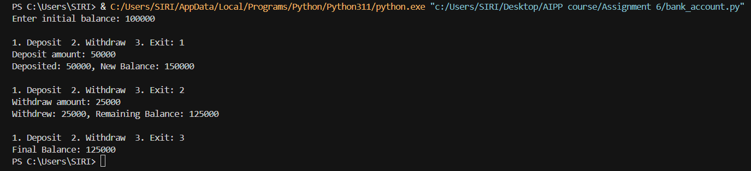  Note: Report should be submitted a word document for all tasks in a single document with prompts, comments & code explaation, and output and if required, screenshots  Evaluation Criteria: |  |  |  |  |  | Week3 - Wednesday
  Criteria | Max Marks
  Class | 1.0
  Loops | 1.0
  Conditional Statements | 0.5
  Total | 2.5 Marks

